*Version* ***24.2.0*** *for the year* ***2024***

­

Prefixbox

SFRA Link Integration

1. Overview 2

1.1 Compatibility 2

1.2 Supported locales 2

2. Components overview 2

3. Setup components 3

3.1 Adding the cartridge in SFCC UX Studio 3

3.2 Assign cartridge to Business Manager 3

3.3 Roles and Permissions from Custom Prefixbox BM module 5

3.4 Import metadata 7

3.5 Services 8

3.6 Jobs 9

3.7 Job run frequency 9

3.8 Job scope 9

4. Custom code and changes. 10

5. Operations, Maintenance and Support 11

5.1 Data storage 11

5.2 Failure/Recovery Process 12

5. 3 Support 12

6. User guide 12

7. Known Issues 13

8. Release History 13

# **Overview**

This document provides the guidelines for the implementation of the Prefixbox (SFRA) Link Integration to Salesforce Commerce Cloud (SFCC).

**Prefixbox AI Search for B2C Commerce** is a fully managed AI Search solution that improves conversion rate and user experience for E-commerce stores.

## **1.1 Compatibility**

This Cartridge works best with the SFRA version of 7.0.0 and compatibility mode 22.7

## **1.2 Supported locales**

This Cartridge supports all locales. Currently it supports a single locale (default locale) per site. That said, no support for multiple locales in the same site.

# **Components overview**

Integration cartridges:

* **int_prefixbox_ai_search**: shared core functionality required for SFRA storefronts and Business Manager module.
* **int_prefixbox_ai_search_sfra:** for SFRA based storefronts only.
* **int_prefixbox_ai_search_sfra_changes:** for SFRA based storefronts changes.
* **bm_prefixbox_ai_search**: Prefixbox custom Business Manager module.
* **int_prefixbox_ai_search_sg:** for Site Genesis based only.
* **int_prefixbox_ai_search_sg_changes:** for Site Genesis based changes.

# **3. Setup components**

Overview of how to setup Prefixbox SFRA LINK cartridges and metadata into Salesforce Commerce Cloud.

## **3.1 Adding the cartridge in SFCC UX Studio**

To upload the cartridges into the SFCC server, you first need to add the cartridges in the SFCC UX Studio. To do this, follow these instructions.

1. In the UX Studio, select ***File > Import***from the menu*.*
2. In the import dialog, select ***General > Existing* *Projects*** in the workspace, and click on 'Next'.
3. Ensure 'Select archive file' is selected and select the compressed cartridge file by clicking on the 'Browse' button.
4. Click on the 'Finish' button to import the cartridges.
5. UX Studio will now ask you if you want to link the cartridge to your active Digital Server connection. Click on ‘yes’ or manually link the cartridge to your server by checking the project under project references in the server connection properties.
6. Wait until UX Studio completes the workspace build and uploads the source codes to the sandbox.

## **3.2 Assign cartridge to Business Manager**

Log into Business Manager

Go to ***Administration > Sites > Manage Sites > Select*** your site from the list “Storefront Sites”.

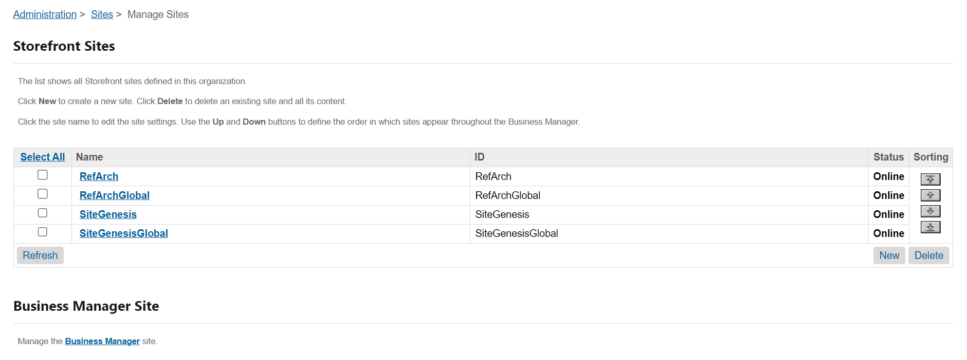  
Select the ***Settings***tab

Add ***int_prefixbox_ai_search***, ***int_prefixbox_ai_search_sfra*** and ***int_prefixbox_ai_search_changes*** to the beginning of the cartridge path.

Make sure it is ordered in the following way:

int_prefixbox_ai_search:int_prefixbox_ai_search_sfra:int_prefixbox_ai_search_sfra_changes

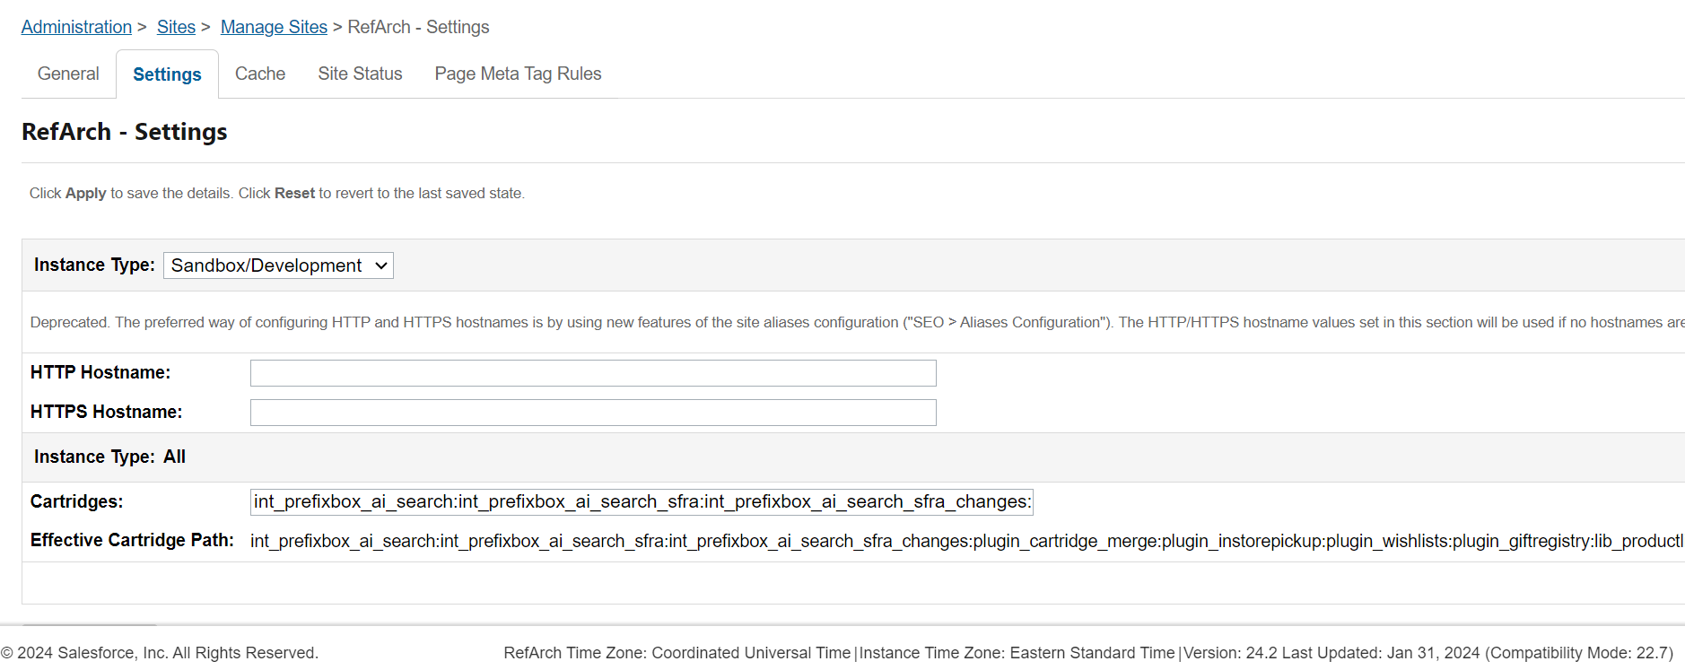

Click ‘Apply’.

Go to ***Administration > Sites -> Manage Sites > Business Manager Site*** > ***Manage the Business Manager site.***

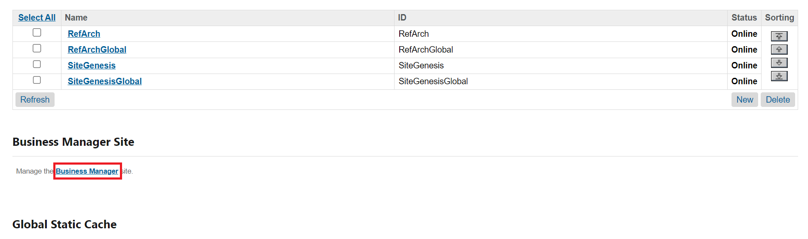

Add ***bm_prefixbox_ai_search*** and ***int_prefixbox_ai_search*** to the beginning of the cartridge path.

Make sure it is ordered in the following way:

int_prefixbox_ai_search:bm_prefixbox_ai_search

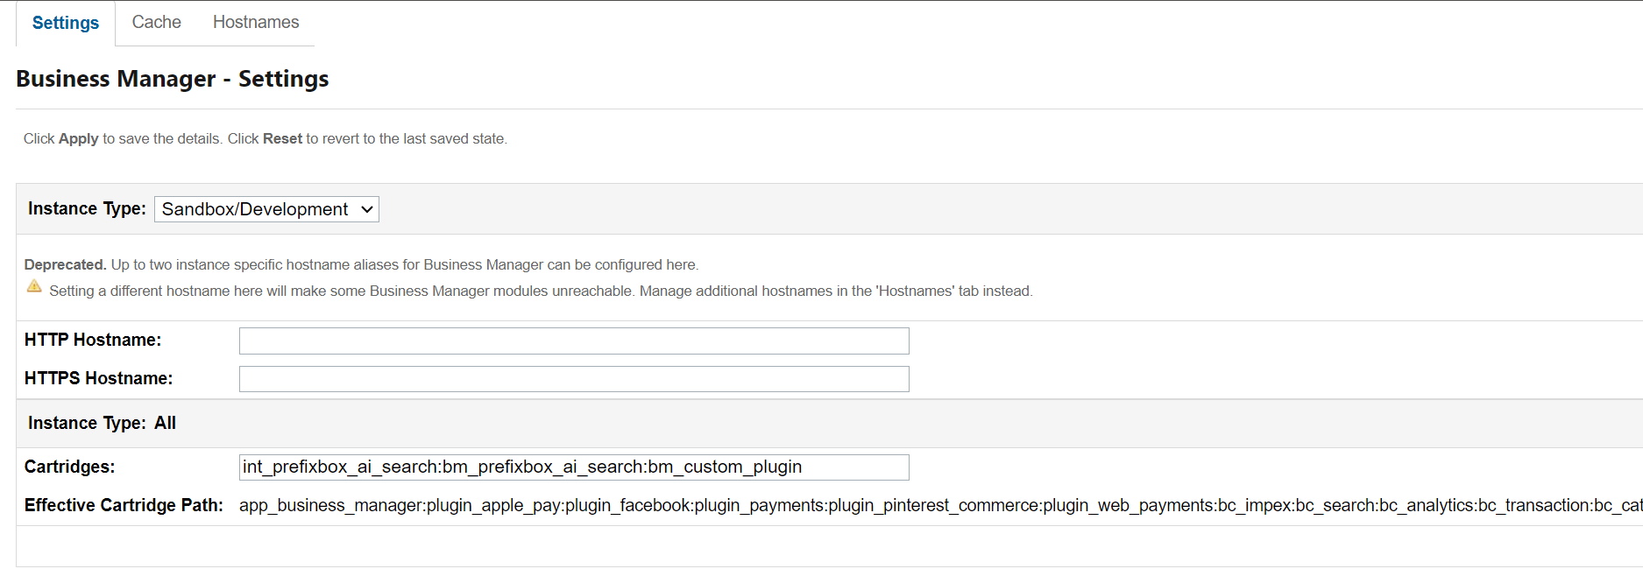

Click ‘Apply’.

**3.3 Roles and Permissions from Custom Prefixbox BM module**

To be able to see the Custom Prefixbox BM module you need to go to ***Administration > Organization > Roles & Permissions***, click on the specified BM user profile (e.g. Administrator).

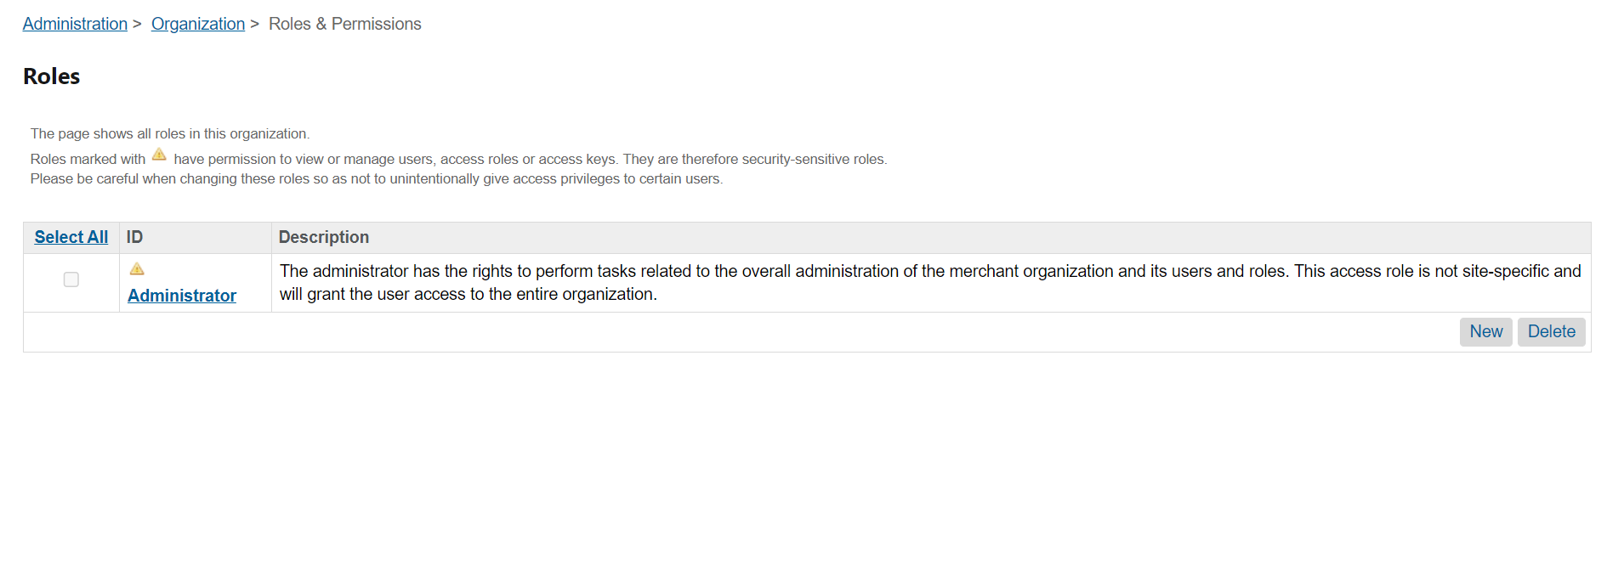

Click to ***Administrator > Business Manager Modules tab*** and select site from modal.

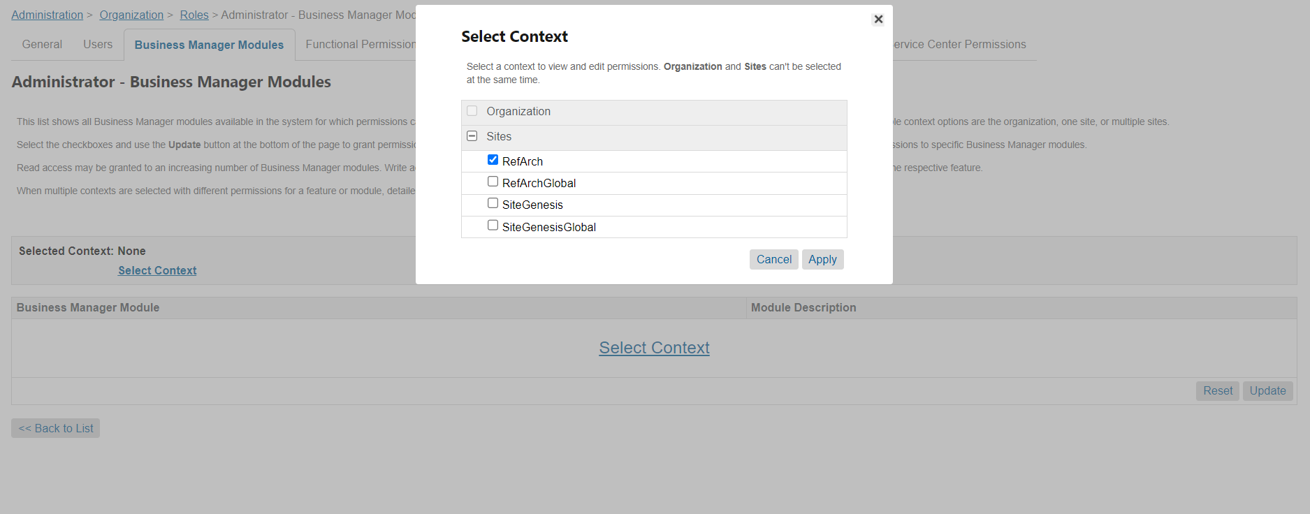

Click ‘Apply’.

Check Prefixbox and press the ‘Update’ button at the end of settings page.

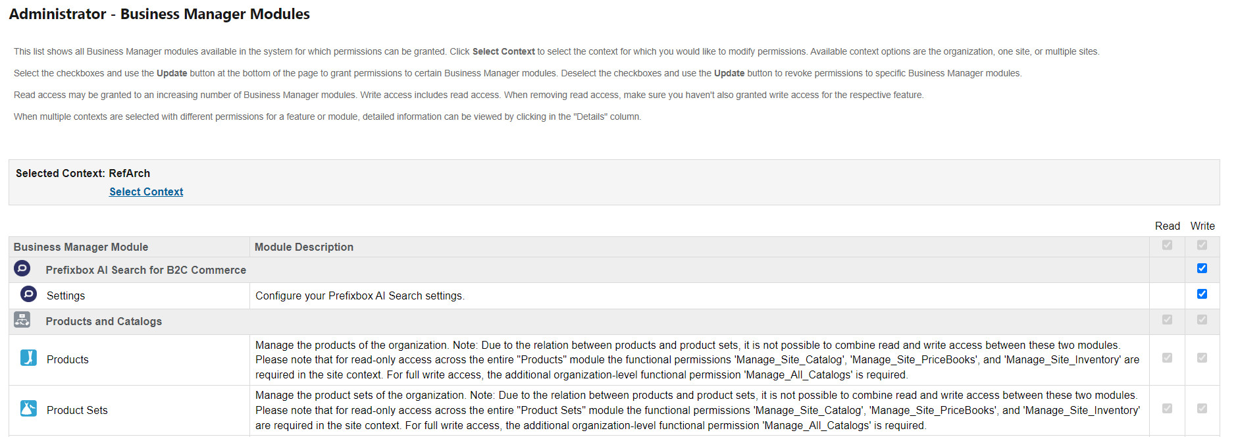

After successfully updating the permissions under ***Merchants Tools*** you should see Prefixbox AI Search for B2C Commerce.

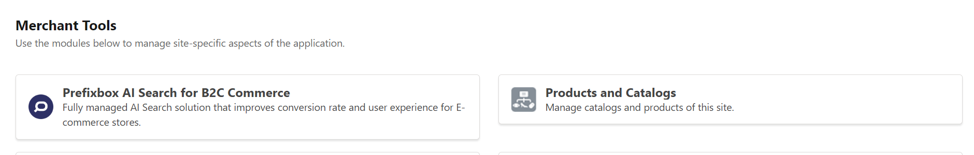

## **3.4 Import metadata**

This step imports all required preferences, services, jobs and profiles to connect Prefixbox with your Salesforce Commerce Cloud.

Go to ***Administration > Site Development > Site Import & Export***. Upload prefixbox.zip from the metadata folder.

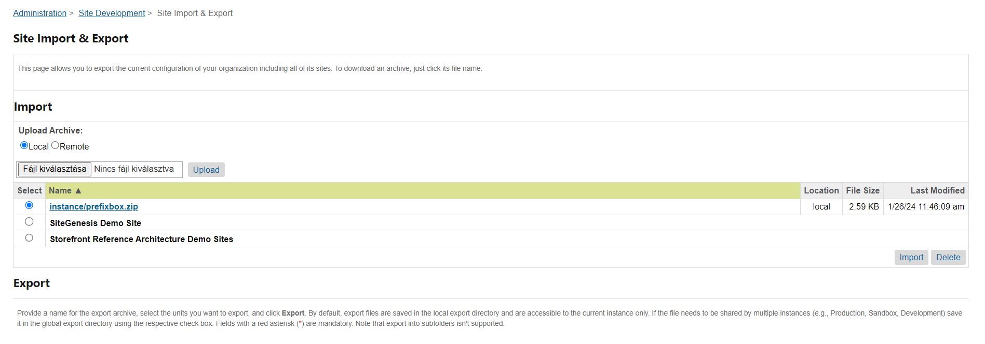

Select **prefixbox.zip** and click 'Import’ to finish the process.

After the import is successfully done, you should see ***Site Preferences in BM > Merchant Tools > Site Preferences > Custom Preferences.***

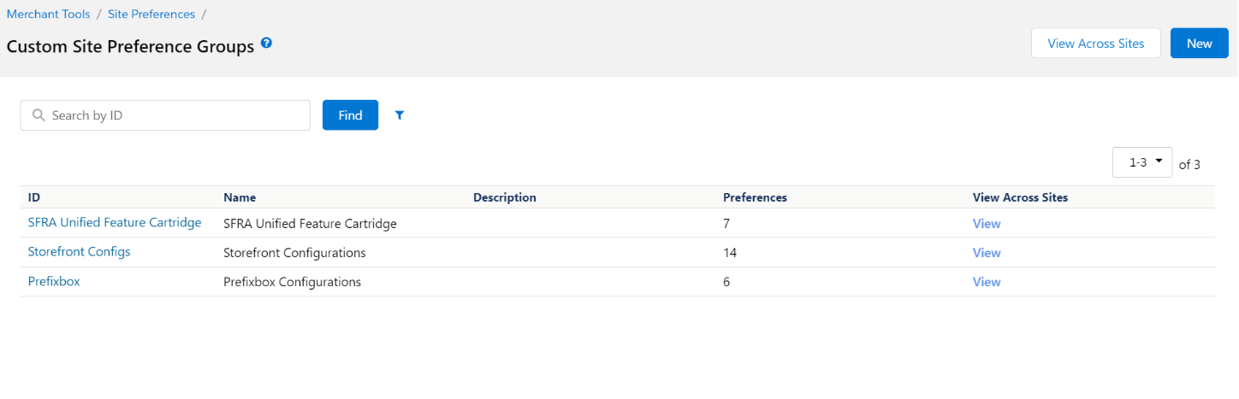

Select ‘Prefixbox’ and you should see fields for the cartridge setup.

***Please use the Prefixbox Custom BM module to configure the search.***

For more information, please follow the user guide you can find below in Section Six.

|  |  |  |
| --- | --- | --- |
| **#** | **Preference Name** | **Description** |
| 1. | PrefixboxEnabled | Enable/disable all Prefixbox functionality |
| 2. | WebsiteTracker | This is a unique identifier for your website that you get from Prefixbox.  To get it, create your account in the [Prefixbox Admin Portal](https://admin.prefixbox.com/). |
| 3. | ApiKey | This is the website API key generated by Prefixbox.  Please keep it secret and use it ONLY from your backend.  This key is used to create, update and DELETE your indices, searches and applications.  You can get it on the [Prefixbox Admin Portal](https://admin.prefixbox.com/) on the ***Website Settings Page.*** |
| 4. | Fields | These are additional attributes of a product.  This is the list of the fields that will be mapped for Prefixbox product feed. |
| 5. | ProductSyncEnabled | Connect your product catalog to Prefixbox. |
| 6 | ProductVariantExport | Enable/disable product variant export. |

**3.5 Services**

Configure Prefixbox Service Credentials. Importing the prefixbox.zip metadata file will create many Prefixbox services, profiles, and credentials.

Verify that the following exists. You can check services, profiles and credentials under ***Administration > Operations > Services***

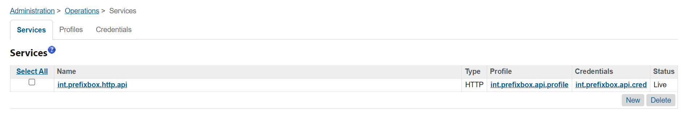Usually, these service definitions do not need to be modified.

## **3.6 Jobs**

There is one SFCC job prepared to build and synchronize products with Prefixbox.

Go to ***Administration > Operations > Jobs >*** ***prefixboxProductExportFull*** for products.



Scripts used for full product export: **int_prefixbox_ai_search/cartridge/scripts/prefixbox/jobs/prefixboxExportProductFull.js**

## **3.7 Job run frequency**

By default, Prefixbox the product export runs every 4 hours, but you can change the job run frequency any time.

To do so, go to ***Administration > Operations > Jobs >*** ***prefixboxProductExportFull > Schedule and History*** and change the settings.

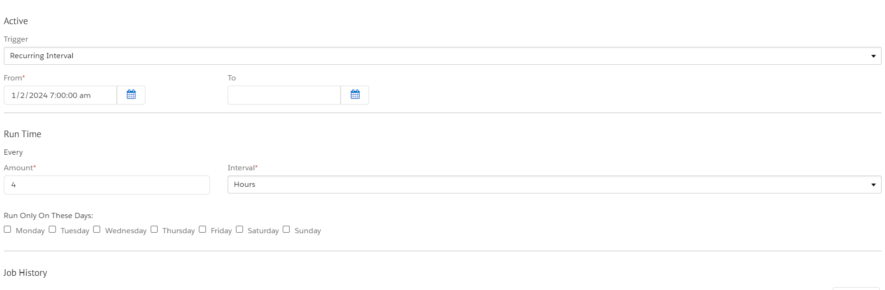

## **3.8 Job scope**

You can change the job scope on your site at any time.

To do so, go to ***Administration > Operations > Jobs >*** ***prefixboxProductExportFull > Schedule and History > Job Steps***

Click:

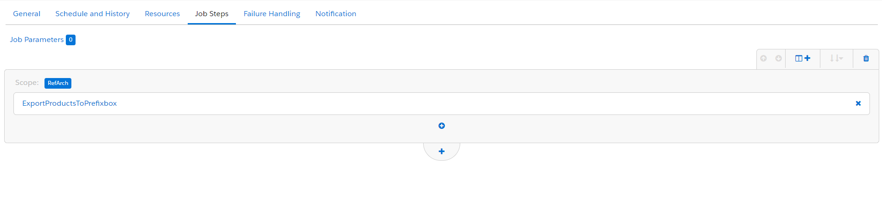

And assign the selected site to the Job.

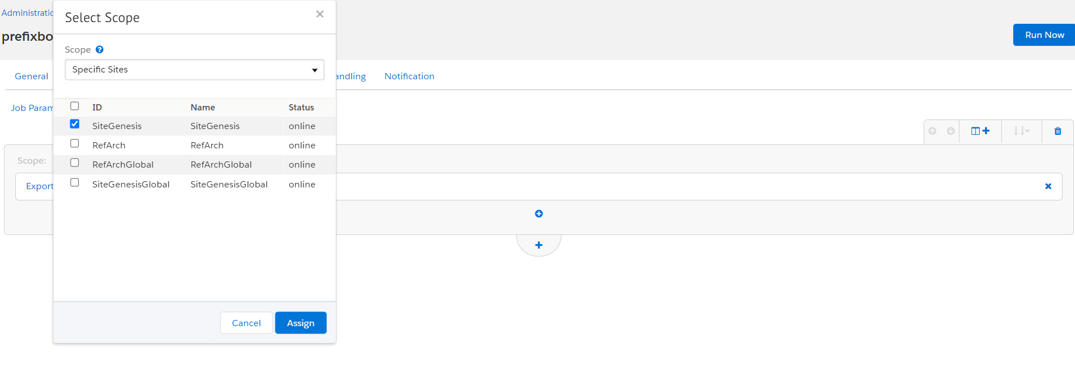

# **4. Custom code and changes.**

The ***int_prefixbox_ai_search_sfra_changes*** cartridge includes a template for Prefixbox’s search.

These will work with a default SFRA installation but may need to be merged into your cartridge(s) if you’ve customized the same templates.

1. app_storefront_base/cartridge/templates/default/common/htmlHead.isml

Insert following snippet bellow to htmlHead.isml

<isinclude template="prefixbox/headerScripts" />

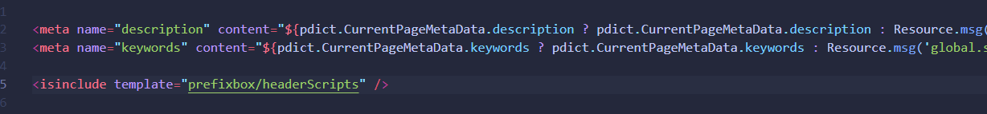

1. app_storefront_base/cartridge/templates/default/components/header/search.isml

Please extend your current search.isml with

**int_prefixbox_ai_seach_sfra_changes/cartridge/templates/default/components/header/search.isml** example template.

And override the snipped code into your overridden app_storefront_base cartridge’s search.isml template.

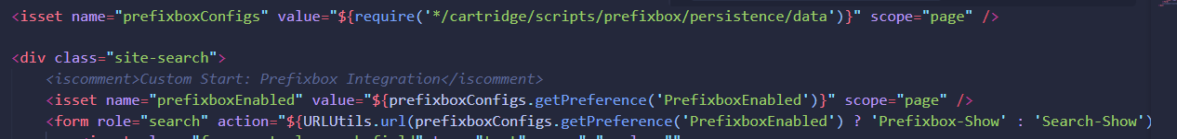

1. app_storefront_base/cartridge/templates/default/search/suggestions.isml

Please extend your current suggestions.isml with

int_prefixbox_ai_search_sfra_changes/cartridge/templates/default/ search/suggestions.isml example template.

And override the snipped code into your overridden app_storefront_base cartridge’s suggestions.isml template.

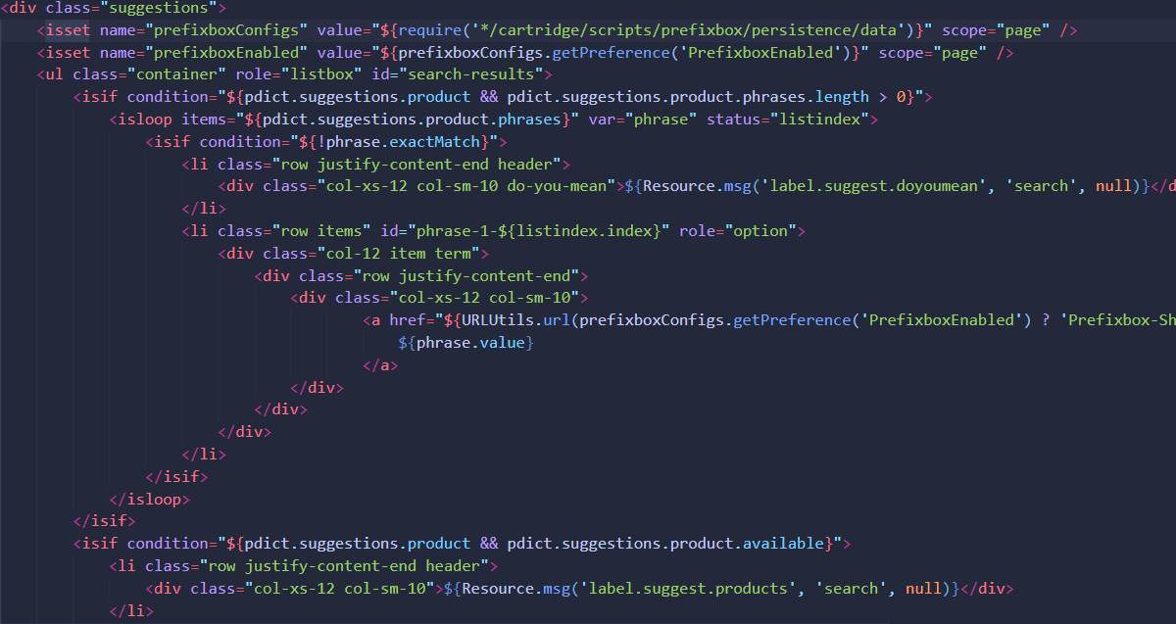

# **5. Operations, Maintenance and Support**

## **5.1 Data storage**

Data used for synchronization between SFCC site and Prefixbox. Site Preferences – the SitePreferences system object has been extended to store setup and confirmation values for each B2C Commerce site.

**5.2 Failure/Recovery Process**

When the cartridge is down then products will not be exported and the search feature will not work.

This will not affect the storefront and the storefront components will work as expected.

If the Prefixbox service becomes unavailable, the storefront search will not function.

In this case, the cartridge should be disabled in ***Site Preferences***, this will bring back the default search functionality until Prefixbox services are back.

**5. 3 Support**

For support, please contact us at support@prefixbox.com.

# **6. User guide**

After installing the cartridge for the first time, you should follow these steps:

1. Register on the [Prefixbox Admin Portal](https://admin.prefixbox.com/).
2. Get credentials from Prefixbox Admin Portal and fill all preferences in Prefixbox custom BM module.
3. Go to Merchants tools > ***Prefixbox AI Search for B2C Commerce > Settings*** and save the credentials.

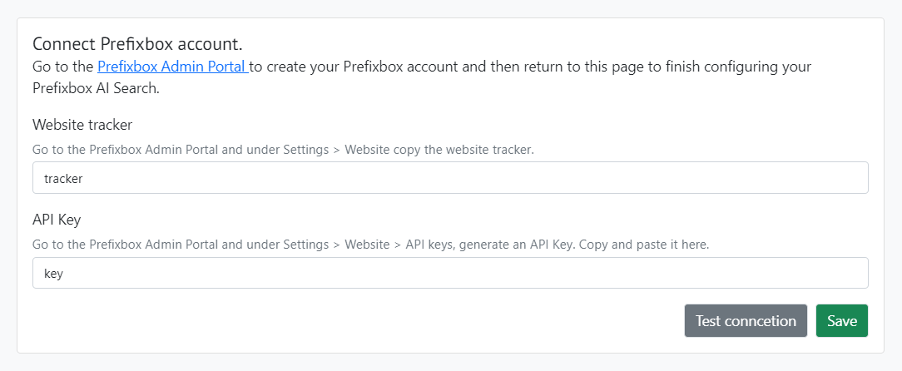

1. Set up the product catalog.

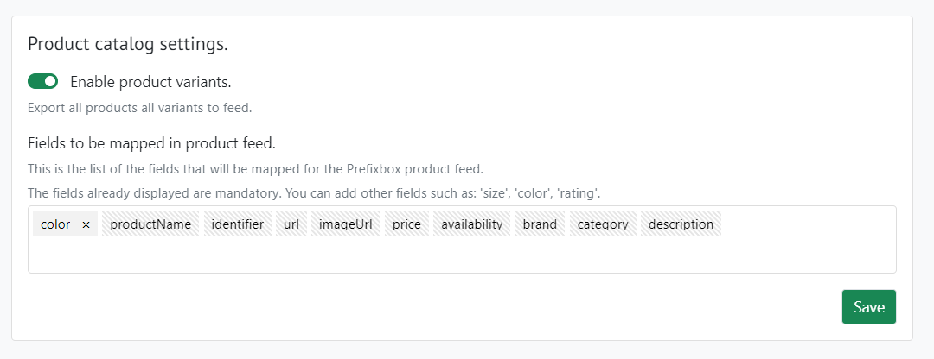

1. Please click Connect product catalog with Prefixbox.
2. After the successful process for faster product catalog export please go to ***Administration > Operations > Jobs > prefixboxProductExportFull*** and run the job manually. This will export your catalog and you can continue to the last step and connect Prefixbox search to your SFCC site.

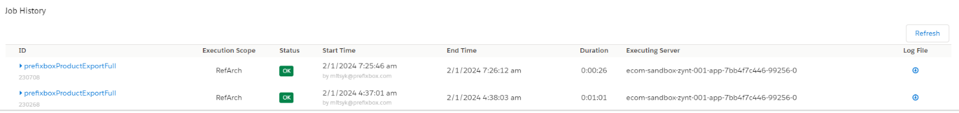

1. After the job is finished, please go back to Prefixbox Custom BM module. After the catalog is successfully created and synchronized,click ‘Connect Search’.

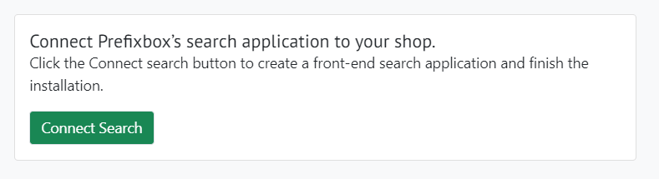

# **7. Known Issues**

There are no known issues.

# **8. Release History**

Version, Date

|  |  |
| --- | --- |
| Version | Date |
| 24.2.0 | 2024.02.01 |